2.What do you understand by Azure Blueprints?

Azure Blueprints is a service from Microsoft Azure that offers a set of built-in components that enable developers to quickly build and scale up new environments with the assurance of complying with organizational policies.
With Azure Blueprints, organizations can define a set of standard configurations, policies, and best practices that can be easily and consistently deployed across multiple subscriptions and environments. It provides a set of pre-built templates that can be used as a starting point or be customized to meet specific requirements.
Azure Blueprints is a service that helps organizations define, manage, and deploy a set of governance and compliance standards across multiple Azure subscriptions in a repeatable and automated way. It ensures that cloud environments are secure, compliant, and consistently configured according to organizational policies.

Key Features of Azure Blueprints:
- Standardized Deployments – Enables organizations to define a repeatable set of policies, role assignments, and resources for consistent deployments.
- Compliance Enforcement – Helps enforce security and compliance by applying policies and controls across subscriptions.
- Integrated with Azure Policy – Works alongside Azure Policy to audit and enforce security and governance requirements.
- Automated Resource Provisioning – Deploys resource groups, role-based access control (RBAC), policies, ARM templates, and scripts as part of a blueprint definition.
- Version Control & Tracking – Allows versioning of blueprints to track changes and improvements over time.
- Locking Mechanism – Prevents unauthorized modification or deletion of assigned resources.

Azure Dedicated Host
Azure Dedicated Host is a fully dedicated physical server provided by Microsoft Azure that is exclusive to a single customer.Azure Dedicated Host ensures complete isolation, giving full control over the underlying hardware.

Key Benefits of Azure Dedicated Host
✅ Isolation & Security – The physical server is dedicated only to your organization, eliminating risks associated with multi-tenant environments.
✅ Compliance & Regulatory Needs – Helps meet compliance requirements (e.g., PCI DSS, HIPAA, ISO, FedRAMP) by ensuring data is hosted on a dedicated machine.
✅ Full Control Over Maintenance – Unlike normal Azure VMs, you get control over host maintenance events, allowing better planning and minimal disruption.
✅ Consistent Performance – Since the resources are not shared, you get predictable CPU, memory, and storage performance.
✅ License Flexibility – You can bring your own Windows Server, SQL Server, and other licenses with Azure Hybrid Benefit to reduce costs.

Azure Advisor
Microsoft Azure that provides personalized best practices and recommendations to optimize your Azure resources.
It analyzes your resource configuration and usage telemetry and then recommends solutions that can help you improve the cost effectiveness, performance, reliability, and security of your Azure resources.
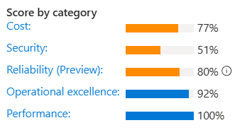
Whenever Advisor detects a new recommendation for one of your resources, an event is stored in the Azure activity log. You can set up alerts for these events from Advisor by using a recommendation-specific alerts creation experience. You can select a subscription and optionally a resource group to specify the resources that you want to receive alerts on.
You can also determine the types of recommendations by using these properties:
- Category
- Impact level
- Recommendation type

Azure Monitor
Azure Monitor is a comprehensive monitoring solution for collecting, analyzing, and responding to monitoring data from your cloud and on-premises environments. You can use Azure Monitor to maximize the availability and performance of your applications and services. It helps you understand how your applications are performing and allows you to manually and programmatically respond to system events.
Azure Monitor collects and aggregates the data from every layer and component of your system across multiple Azure and non-Azure subscriptions and tenants. It stores it in a common data platform for consumption by a common set of tools that can correlate, analyze, visualize, and/or respond to the data. You can also integrate other Microsoft and non-Microsoft tools.
Key Features of Azure Monitor
- Data Collection
  - Gathers telemetry data from various sources like Azure resources, virtual machines, and applications.
  - Supports metrics (numerical data) and logs (event-based data).
- Visualization
  - Azure Monitor Dashboards: Custom dashboards for real-time data insights.
  - Workbooks: Interactive reports combining logs and metrics.
  - Metrics Explorer: Graphs and visualizes metrics.
- Analysis & Insights
  - Log Analytics: Uses Kusto Query Language (KQL) to analyze large log datasets.
  - Application Insights: Monitors application performance and tracks dependencies.
- Alerting & Notifications
  - Alerts: Detect issues using thresholds on logs and metrics.
  - Smart Alerts with AI: Uses machine learning to detect anomalies.
  - Notifications: Sends alerts via email, SMS, webhooks, or ITSM tools.
- Automation & Remediation
  - Autoscale: Adjusts resources automatically based on demand.
  - Azure Logic Apps & Functions: Automates responses to alerts.
- Integration & Extensibility
  - Works with tools like Grafana, Power BI, Prometheus, and external monitoring solutions.
  - Supports API and SDKs for custom monitoring.
How Azure Monitor Works?
- Collect: Gathers data from applications, infrastructure, and network.
- Analyze: Uses AI and analytics to find trends, anomalies, and root causes.
- Respond: Triggers alerts, notifications, or automated actions.
- Optimize: Helps in resource scaling, cost optimization, and performance tuning.
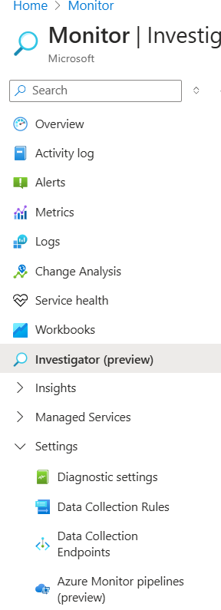

✅ 1. Private Link
Azure Private Link enables private access to Azure services over the Microsoft backbone network, without exposing traffic to the public internet.
✅ 2. Private Endpoint
A Private Endpoint is a network interface with a private IP address from your VNet that provides secure access to an Azure service using Azure Private Link.
It allows resources within your VNet to privately connect to Azure services like Storage, SQL, Key Vault, etc., without traversing the internet.

✅ 3. Private Link Service
A Private Link Service is used to expose your own service hosted behind a Standard Load Balancer privately to consumers in other VNets or tenants via Private Endpoints.
It allows secure, scalable, and private publishing of internal applications or partner services over Azure Private Link.

🧠 Bonus: Relationship Between Them (interview-friendly explanation)
When you create a Private Endpoint, Azure automatically establishes a Private Link in the backend.
If you want others to connect to your own service privately, you set up a Private Link Service, and they connect via their Private Endpoint.

🧠 Think of it like:
- Private Endpoint = Your private IP in your VNet.
- Private Link = The secure tunnel that connects your private IP to the Azure service.

Can a service in one VNet be accessed from another VNet using Private Endpoint?
Yes, an Azure service (like Storage Account, SQL Database, etc.) in one VNet can be accessed privately from another VNet using a Private Endpoint.

🧠 Interview Definition / Explanation:
A Private Endpoint enables you to access Azure services across VNets securely over the Microsoft backbone, even if the service is in a different VNet or region.
It does this by assigning a private IP from your local VNet to the target Azure service, and Azure Private Link handles the secure connection in the background.

📌 Cross-VNet Access Example:
- ✅ VNet A: Contains your Private Endpoint.
- ✅ VNet B: Has the Storage Account or SQL Database.
- 🔒 The Private Endpoint in VNet A connects to the service in VNet B privately, without using the internet.

🔐 Key Benefits:
- No need for VNet Peering.
- Traffic stays entirely within Azure's private backbone.
- Enhanced security, isolation, and compliance.

🎯 Example:
You have an Azure SQL Database in East US.
You create a Private Endpoint in a VNet in West Europe.
Now VMs in the West Europe VNet can connect to the SQL DB privately, using the Private Endpoint IP.

✅ Where is Private Link Service Used?
Private Link Service is used when you are publishing your own custom application or service (hosted in Azure) for private access by other VNets or tenants.

🔧 Example Where Private Link Service is Used:
Let’s say you have a custom web app or API hosted in a VNet behind a Standard Load Balancer.
- You want other teams, customers, or business units to access your service privately from their own VNets.
- You create a Private Link Service in front of your app.
- They create a Private Endpoint in their own VNet and connect it to your Private Link Service.
- Now their traffic is routed privately over Azure’s backbone, just like with PaaS services.

Private Endpoint DNS integration over Point to Site VPN connection
Point to Site VPN name resolution behavior
By design Azure VPN client will set and use DNS servers that are either set on Virtual Network DNS Server or specified in client XLM profile. In case your Virtual Network is set to use Azure Provided DNS (168.63.129.16) you will not be able to resolve Private Endpoint. In case you don’t want to define DNS at the VNET level, you can still set DNS Server configuration directly on client XLM profile, and set the IP to a DNS Forwarder/Proxy running on Azure.
Name Resolution Validation
Use PowerShell command:
Resolve-DnsName -Name ["Blob storage account FQDN name"] -DnsOnly

For name resolution
Solution 1: Specify DNS Server for the Virtual Network
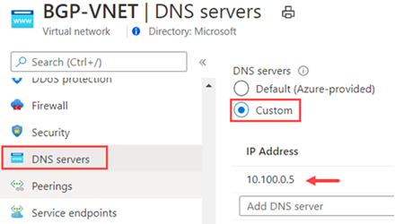
Solution 2: Specify DNS Server inside VPN Client Profile
<clientconfig>
<dnsservers>
<dnsserver>10.100.0.5</dnsserver>
</dnsservers>
</clientconfig>

Route table
An Azure Route Table (also called a User-Defined Route or UDR) allows you to control traffic routing within your Azure Virtual Network (VNet).
🧠 Why Use a Route Table?
By default, Azure automatically handles routing between subnets, VNets, and the internet. But if you want custom routing—like forcing traffic through a firewall, NVA, or VPN—you use a route table.

🧩 Key Components:
Component | Description
Route Table | A container that holds one or more custom routes
Route | A rule inside the table that defines where traffic should go
Address Prefix | The destination IP range for the traffic (e.g., 10.0.2.0/24)
Next Hop Type | Defines how to reach that destination (e.g., VirtualAppliance, Internet)
Next Hop IP | Used only for some hop types (e.g., the private IP of a firewall VM)
Subnet Association | You must associate a route table with a subnet for it to apply

